Software Requirements Specification

For

TOURISMO
(Tour Booking System)

Prepared by :-
Raymond Joy

TABLE OF CONTENTS

- INTRODUCTION 3
1.1 PURPOSE 3
1.2 SCOPE 3
1.3 OBJECTIVES 3
2. FUNCTIONAL REQUIREMENTS 3
2.1 PRIMARY ACTORS OF THE SYSTEM 3
2.2 USE CASE DIAGRAMS 4
2.3 USER STORIES 7
2.4 BUSINESS PROCESS DIAGRAM 10
3. NON-FUNCTIONAL REQUIREMENTS 10
4. TECHNICAL REQUIREMENTS 12
5. CONCLUSION 13

1. INTRODUCTION
1.1 PURPOSE
This Software Requirements Specification (SRS) document details the functional and non-functional requirements for the TOURISMO Tour Booking System (TBS). It serves as a foundational blueprint for developers, system architects, project managers, and key stakeholders (Agency, Consultant, and Customer).
1.2 SCOPE
The TOURISMO Tour Booking System is a web-based and mobile-accessible platform that automates tour management, booking reservations, customer support, and payment processes. It streamlines communication between customers seeking tour packages, travel consultants managing reservations, and the overall agency managing packages and system rules.
1.3 OBJECTIVES
- Automate end-to-end tour package booking, cancellation, and payment processing.
- Provide tailored user roles for Agency Administrators, Travel Consultants, and Customers.
- Enhance operational efficiency and lower administrative overhead for travel agencies.
- Provide real-time reporting, inventory management, and communication channels.

2. FUNCTIONAL REQUIREMENTS
2.1 PRIMARY ACTORS OF THE SYSTEM
- Agency: The admin body responsible for defining tour packages, setting pricing schedules, overseeing consultants, and analyzing operational metrics.
- Consultant: The intermediary agent who assists customers, customizes tour itineraries, confirms bookings, and handles customer inquiries.
- Customer: The end-user who browses packages, requests customized quotes, books tours, and makes secure payments.
2.2 USE CASE DIAGRAMS
AGENCY
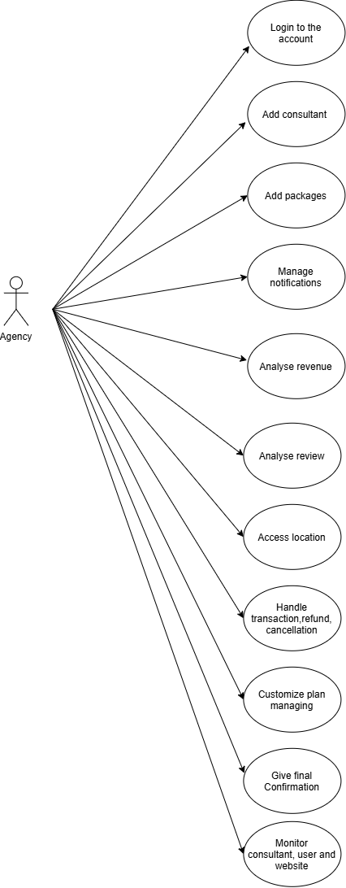
CONSULTANT
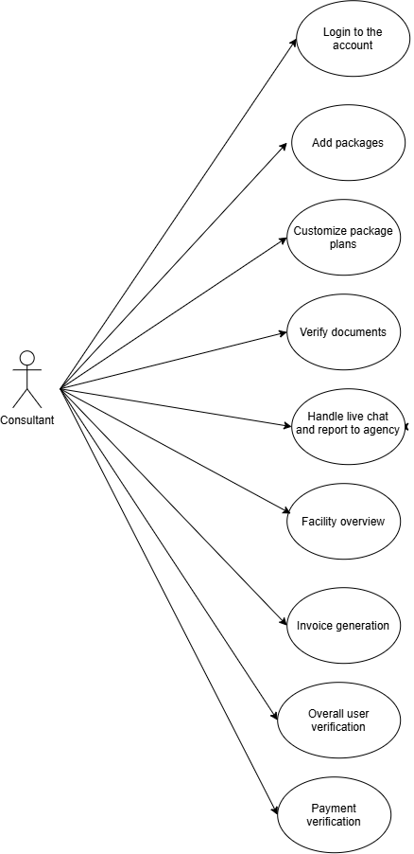
CUSTOMER
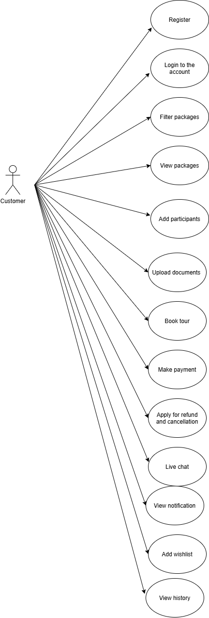
2.3 USER STORIES
AGENCY
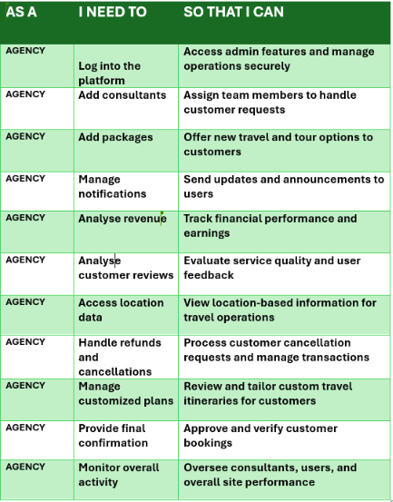

CONSULTANT
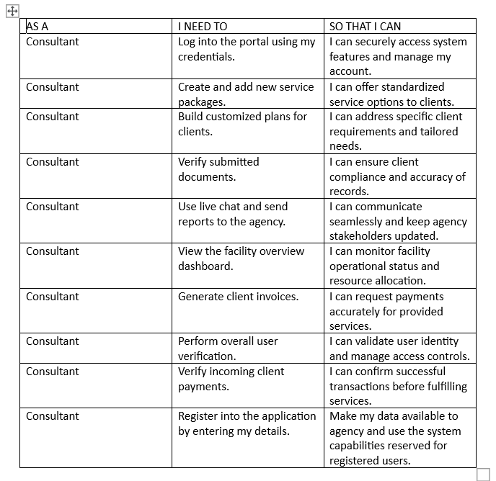

CUSTOMER
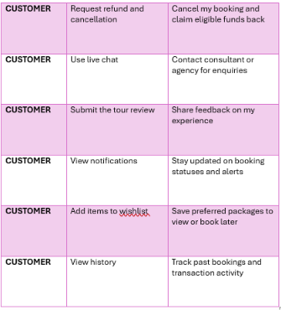

2.4 BUSINESS PROCESS DIAGRAM
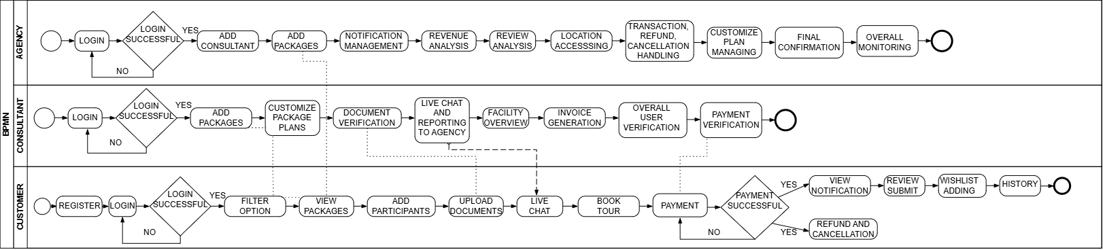

3. NON-FUNCTIONAL REQUIREMENTS
These requirements ensure that the system performs efficiently, securely, and reliably while providing a good user experience.

1. Performance Requirements
⧫ The system should respond to user requests within a few seconds under normal operating conditions.
⧫ The application should support multiple users accessing the system simultaneously without significant performance degradation.
⧫ Tour package searches and booking operations should be processed efficiently and accurately.
⧫ The system should be capable of handling increasing user traffic and booking data.

2. Reliability Requirements
⧫ The system should provide consistent and accurate services with minimal downtime.
⧫ Booking, payment, and refund information should be stored reliably without data loss.
⧫ The system should recover properly from failures or unexpected shutdowns.
⧫ Backup and recovery mechanisms should be implemented to protect important data.

3. Security Requirements
⧫ Users must log in using secure authentication methods.
⧫ Customer data, payment details, and personal information should be protected from unauthorized access.
⧫ The system should provide role-based access control for customers, consultants, and agency admins.
⧫ Secure communication protocols should be used for online transactions and data transfer.
⧫ The system should maintain proper records of user activities and transactions.

4. Usability Requirements
⧫ The system should provide a simple, user-friendly, and attractive interface.
⧫ Users should be able to navigate the system easily without technical knowledge.
⧫ Error messages and instructions should be clear and understandable.
⧫ The application should support easy access to booking, payment, and feedback features.

5. Availability Requirements
⧫ The system should be available to users at all times except during scheduled maintenance.
⧫ The application should support continuous online access for booking and customer services.

6. Scalability Requirements
⧫ The system should support future expansion, such as adding more users, tour packages, and travel services.
⧫ The database and server infrastructure should be capable of handling increased workload.
4. TECHNICAL REQUIREMENTS
1. Hardware Requirements
Server Side
➨ Processor: Intel Core i5 or higher
➨ RAM: Minimum 8 GB
➨ Storage: Minimum 500 GB hard disk or SSD
➨ Network: Stable internet connection with adequate bandwidth
Client Side
➨ Computer, laptop, tablet, or smartphone
➨ Minimum 4 GB RAM
➨ Stable internet connection
➨ Web browser support

2. Software Requirements
Operating System
➨ Windows 10/11
Web Browsers
➨ Google Chrome
➨ Mozilla Firefox
➨ Microsoft Edge
Database Management System
➨ PostgreSQL

3. Programming languages
Frontend
➨ HTML
➨ CSS
➨ JAVASCRIPT
Backend
➨ Python

4. Frameworks and technologies
➨ Bootstrap for responsive user interface
➨ React for front end development
➨ FastAPI for communication between frontend and backend systems

5. Compatibility Requirements
➨ The system should support desktop and mobile devices.
➨ The application should function properly across multiple operating systems and web browsers.

6. Security Requirements
➨ SSL/TLS encryption should be used for secure communication.
➨ Passwords should be stored in encrypted format.
➨ Secure authentication and authorization mechanisms should be implemented.
➨ The system should support secure online payment gateway integration.

5. CONCLUSION
The Software Requirements Specification provides a blueprint for building a scalable, reliable, and user-friendly TOURISMO Tour Booking System. By directly addressing the workflows of the Agency, Consultant, and Customer, the platform ensures streamlined operations and an enhanced tour reservation experience.

